NUID: 002773368

Name: Cheng Yuxuan

This is the report for INFO6205 Assignment 3. Three parts will be discussed seperately as followed.

Part 1.

By reading the code thoroughly, we had that the get clock method returns a simple System.nanoTime(), and the toMillisecs transfers a ticks \* 1e-6.

The repeat(n, supplier, function, prefunction, postfunction) function is comparably more complex. In the loop of n, by calling the supplier function and get resulting value, we pause the timer and check if prefunction is null; Then we resume the timer and then apply the function to record its time. After that we check post function exists or not, and then record the mean lap time & return it.

The test case passed screenshot are shown below:

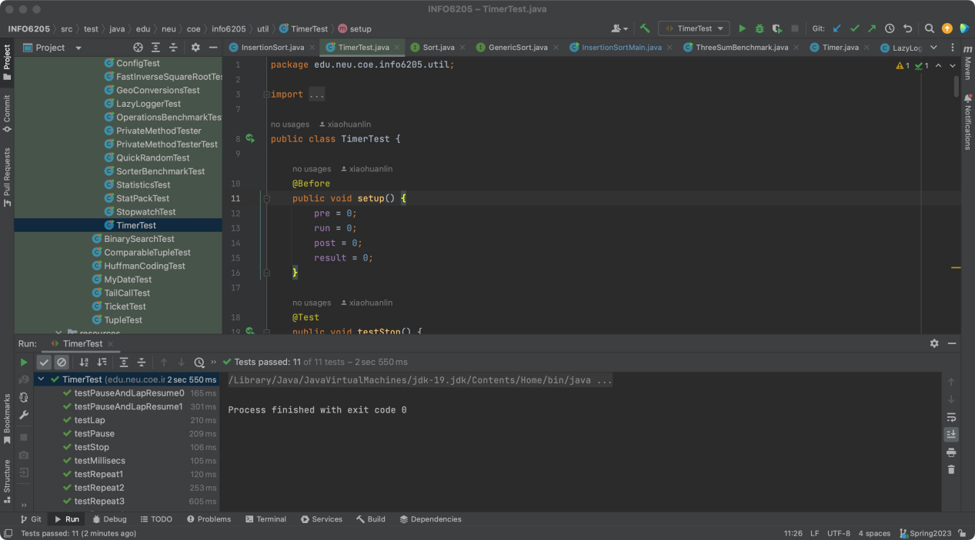

Part 2.

This part requires us to implement the insertion sort. In the loop of array’s length, each time after comparing the current value and the next value, we operate on the array. If the former one is larger than next one we insert the next value to the appropriate position ( so that the former part of array is sorted). This action applies the least compare times: the same as the length of array; however, each insertion should require O(n) times of swap, which makes this type of sort has O(n^2) time complexity.

The test-passed screen shot are shown as below:

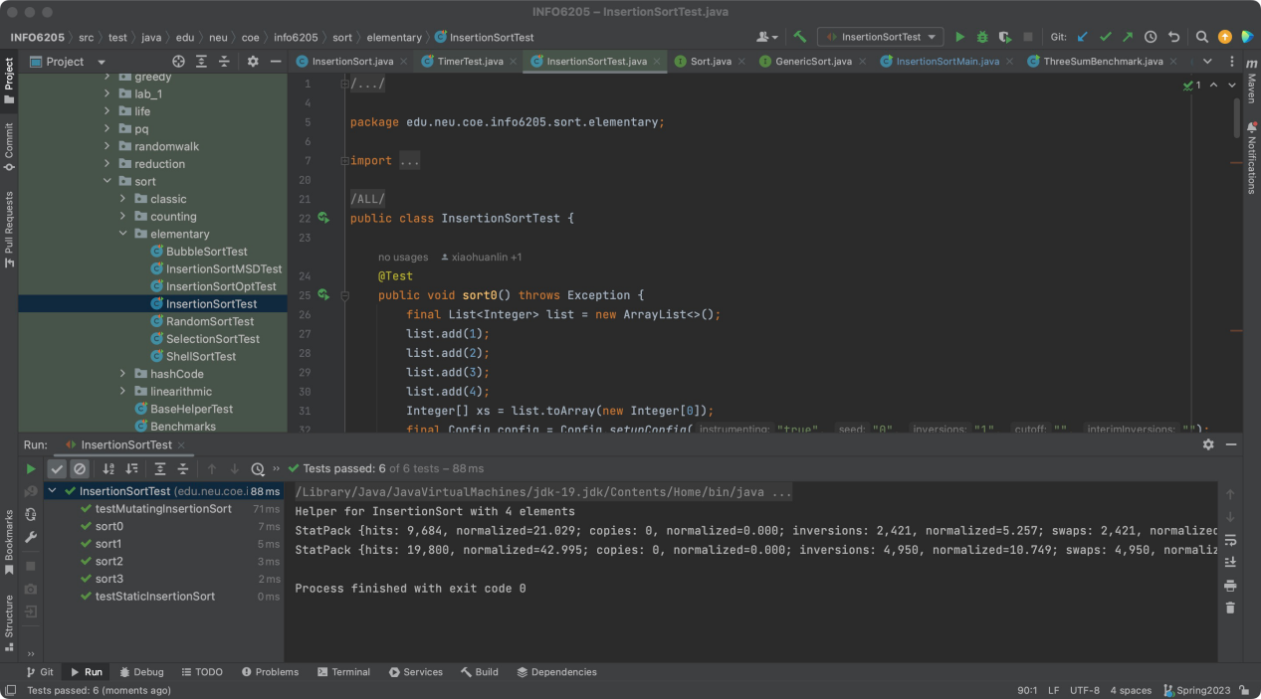

Part 3.

We wrote a new class named “InsertionSortMain.java” and define our own Arrays for sorting in our main class. We declare a int [][] named tests[5][]. the tests[5][] contains 5 different int[] array with various length (to satisfy the requirements of double-length method). The test[0] is length of 200 and test[1] is at length of 400.. and so on. Finally we have the length of test[4] is 3200. We will sort all arrays in tests next.

We wrote private static void runsorts(String typeofarrayString, Integer[][] tests) to run the 4 different times as “random array, sorted array, sorted reversed array, and partially sorted array”. In this method we apply the for loop to iterate all elements in tests[][].

Before the test we call timer.repeat() to warm-up the computer by running sorting action for 1000 times, at the begining of our test.

The screenshot of running the main method is as followed:

The running time result is recorded in appendix part.

By analyzing the result we have that the “reversed arrays” has the longest running time - when the array goes longer, the avarage running time() increases from around 0.20 to 5.35.

The sorted array returns the stable and least runtime from 0.17 to 0.57.

The random sort array returns the runtime (when array grows longer) from 0.12 to 3.01.

The partial sort array returns the runtime (when array grows longer) from 0.14 to 2.72.

Overall the runtime period of these 4 types are reversed > random > partial > sorted.

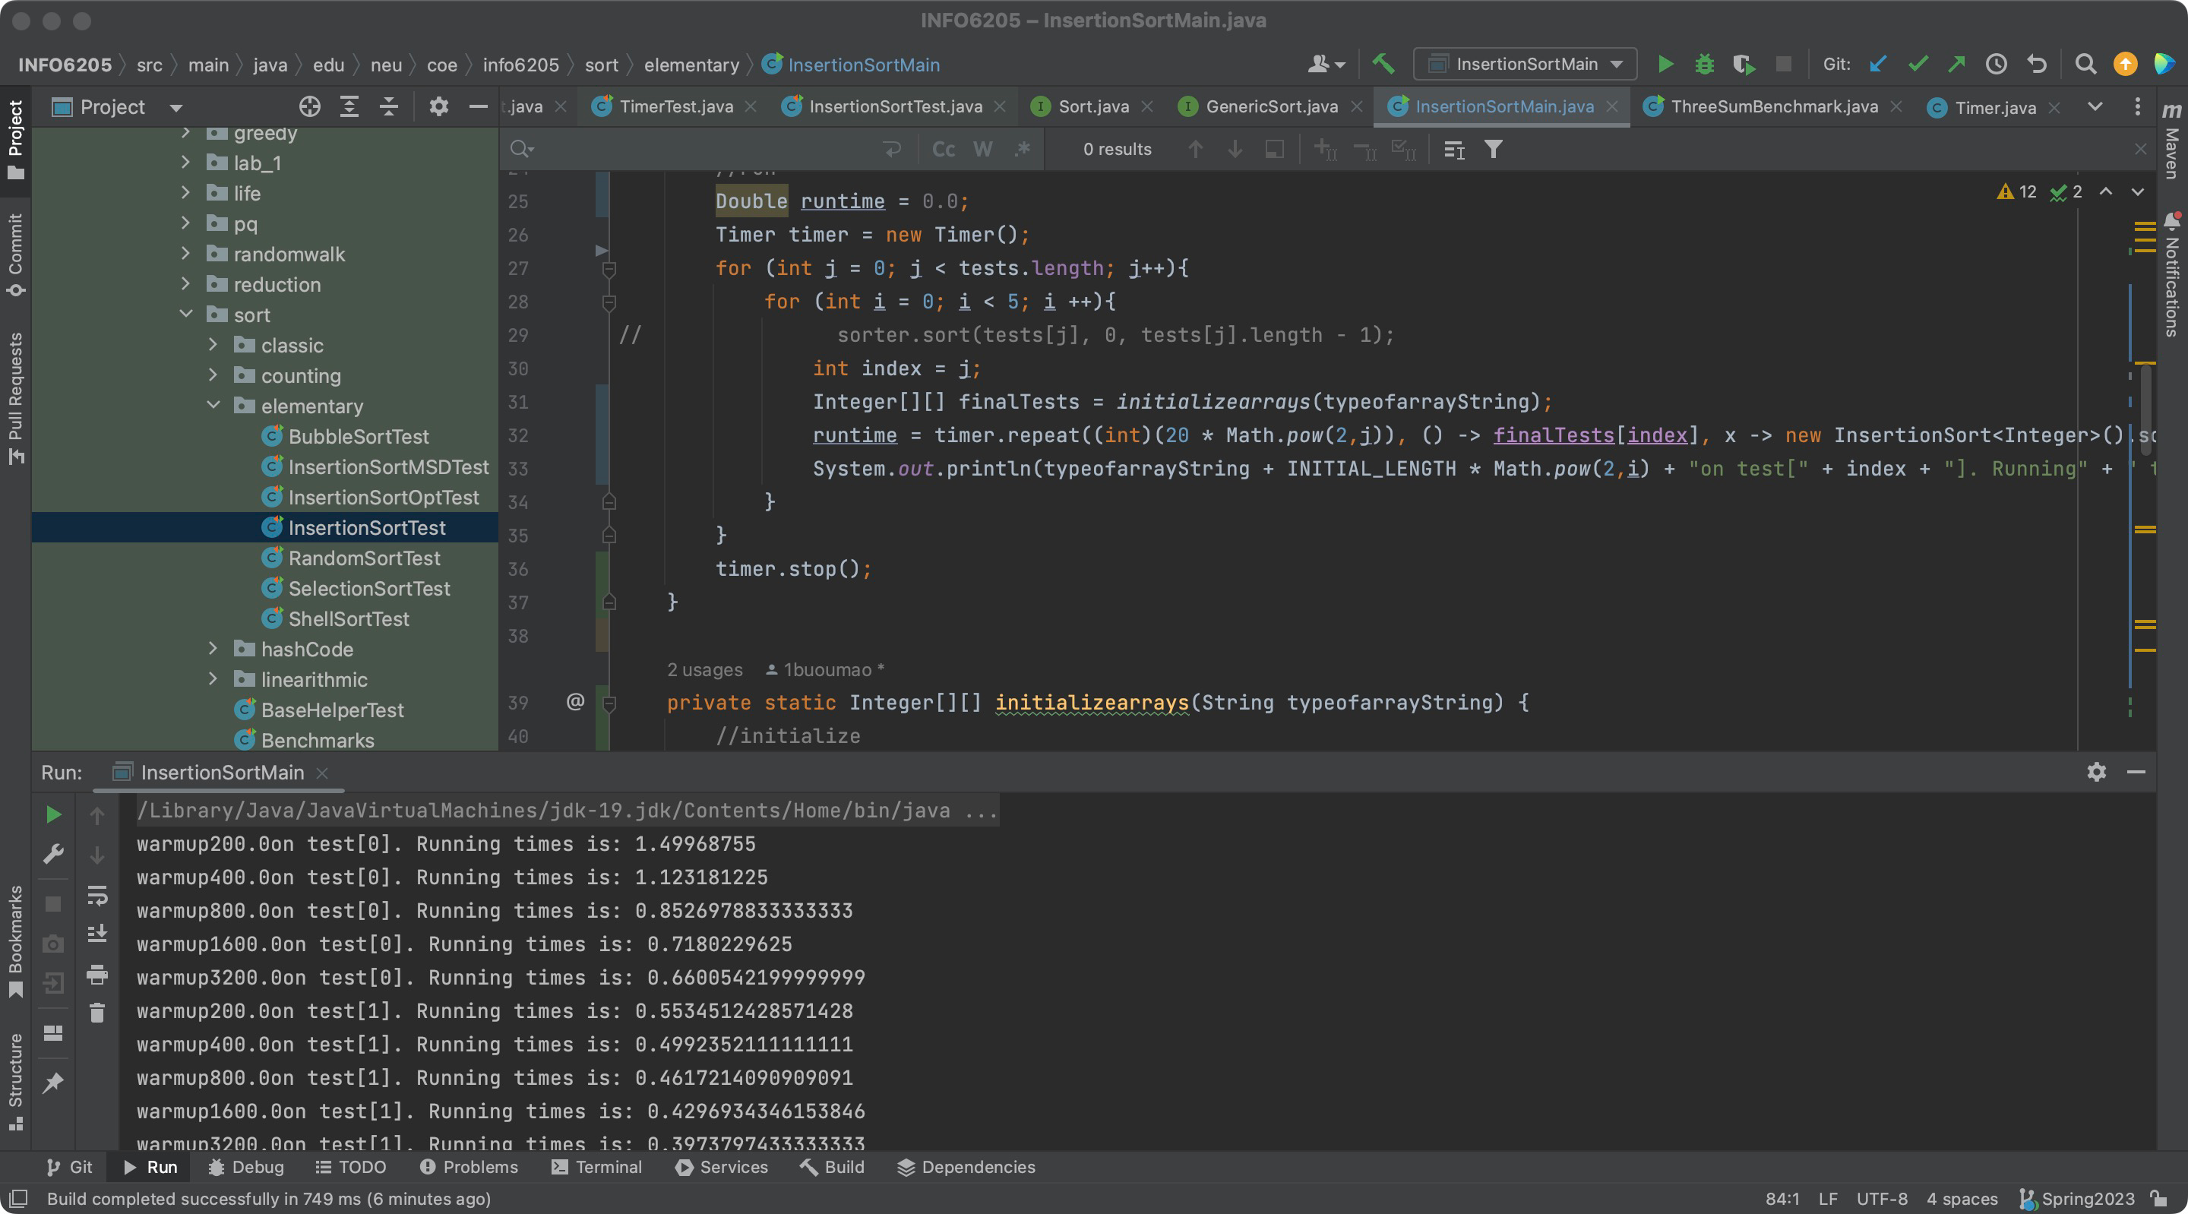

Appendix.

warmup200.0on test[0]. Running times is: 1.49968755

warmup400.0on test[0]. Running times is: 1.123181225

warmup800.0on test[0]. Running times is: 0.8526978833333333

warmup1600.0on test[0]. Running times is: 0.7180229625

warmup3200.0on test[0]. Running times is: 0.6600542199999999

warmup200.0on test[1]. Running times is: 0.5534512428571428

warmup400.0on test[1]. Running times is: 0.4992352111111111

warmup800.0on test[1]. Running times is: 0.4617214090909091

warmup1600.0on test[1]. Running times is: 0.4296934346153846

warmup3200.0on test[1]. Running times is: 0.3973797433333333

warmup200.0on test[2]. Running times is: 0.40955624999999996

warmup400.0on test[2]. Running times is: 0.4154118695652174

warmup800.0on test[2]. Running times is: 0.41869159629629626

warmup1600.0on test[2]. Running times is: 0.4177181612903226

warmup3200.0on test[2]. Running times is: 0.41883436571428573

warmup200.0on test[3]. Running times is: 0.5993561732558139

warmup400.0on test[3]. Running times is: 0.7166462901960784

warmup800.0on test[3]. Running times is: 0.8031291008474576

warmup1600.0on test[3]. Running times is: 0.8651264664179104

warmup3200.0on test[3]. Running times is: 0.9166262279999999

warmup200.0on test[4]. Running times is: 1.6825419241758242

warmup400.0on test[4]. Running times is: 2.186533141121495

warmup800.0on test[4]. Running times is: 2.5811986130081297

warmup1600.0on test[4]. Running times is: 2.8800890007194244

warmup3200.0on test[4]. Running times is: 3.1250629741935483

Random array runtime at 200.0on test[0]. Running times is: 0.12810405

Random array runtime at 400.0on test[0]. Running times is: 0.125635375

Random array runtime at 800.0on test[0]. Running times is: 0.12569165

Random array runtime at 1600.0on test[0]. Running times is: 0.1260780875

Random array runtime at 3200.0on test[0]. Running times is: 0.12666584

Random array runtime at 200.0on test[1]. Running times is: 0.13184939285714284

Random array runtime at 400.0on test[1]. Running times is: 0.13546039999999998

Random array runtime at 800.0on test[1]. Running times is: 0.13801742727272726

Random array runtime at 1600.0on test[1]. Running times is: 0.14080771153846156

Random array runtime at 3200.0on test[1]. Running times is: 0.14177460333333333

Random array runtime at 200.0on test[2]. Running times is: 0.19280067368421053

Random array runtime at 400.0on test[2]. Running times is: 0.2257507260869565

Random array runtime at 800.0on test[2]. Running times is: 0.24919127407407407

Random array runtime at 1600.0on test[2]. Running times is: 0.2678733822580645

Random array runtime at 3200.0on test[2]. Running times is: 0.27986784857142855

Random array runtime at 200.0on test[3]. Running times is: 0.4737937848837209

Random array runtime at 400.0on test[3]. Running times is: 0.6060165372549019

Random array runtime at 800.0on test[3]. Running times is: 0.7059247881355931

Random array runtime at 1600.0on test[3]. Running times is: 0.7853631880597014

Random array runtime at 3200.0on test[3]. Running times is: 0.8433897846666667

Random array runtime at 200.0on test[4]. Running times is: 1.594657289010989

Random array runtime at 400.0on test[4]. Running times is: 2.136699969626168

Random array runtime at 800.0on test[4]. Running times is: 2.5505504678861786

Random array runtime at 1600.0on test[4]. Running times is: 2.8366992323741007

Random array runtime at 3200.0on test[4]. Running times is: 3.01605334516129

Sorted array runtime at 200.0on test[0]. Running times is: 0.17302495

Sorted array runtime at 400.0on test[0]. Running times is: 0.16066985

Sorted array runtime at 800.0on test[0]. Running times is: 0.15609515

Sorted array runtime at 1600.0on test[0]. Running times is: 0.1548213625

Sorted array runtime at 3200.0on test[0]. Running times is: 0.15337915

Sorted array runtime at 200.0on test[1]. Running times is: 0.13546310714285714

Sorted array runtime at 400.0on test[1]. Running times is: 0.12552292222222222

Sorted array runtime at 800.0on test[1]. Running times is: 0.11909622272727273

Sorted array runtime at 1600.0on test[1]. Running times is: 0.11476410769230769

Sorted array runtime at 3200.0on test[1]. Running times is: 0.11475194333333331

Sorted array runtime at 200.0on test[2]. Running times is: 0.10589033684210525

Sorted array runtime at 400.0on test[2]. Running times is: 0.10027670869565217

Sorted array runtime at 800.0on test[2]. Running times is: 0.0969068611111111

Sorted array runtime at 1600.0on test[2]. Running times is: 0.09452062096774193

Sorted array runtime at 3200.0on test[2]. Running times is: 0.09265767142857144

Sorted array runtime at 200.0on test[3]. Running times is: 0.08562571511627907

Sorted array runtime at 400.0on test[3]. Running times is: 0.08087785784313725

Sorted array runtime at 800.0on test[3]. Running times is: 0.07646260677966102

Sorted array runtime at 1600.0on test[3]. Running times is: 0.07315653208955224

Sorted array runtime at 3200.0on test[3]. Running times is: 0.07054917333333333

Sorted array runtime at 200.0on test[4]. Running times is: 0.0668531489010989

Sorted array runtime at 400.0on test[4]. Running times is: 0.06358831028037383

Sorted array runtime at 800.0on test[4]. Running times is: 0.061386817479674796

Sorted array runtime at 1600.0on test[4]. Running times is: 0.05942155791366906

Sorted array runtime at 3200.0on test[4]. Running times is: 0.057769982580645154

Reversed array runtime at 200.0on test[0]. Running times is: 0.2088812

Reversed array runtime at 400.0on test[0]. Running times is: 0.21250095

Reversed array runtime at 800.0on test[0]. Running times is: 0.21661529999999998

Reversed array runtime at 1600.0on test[0]. Running times is: 0.239788575

Reversed array runtime at 3200.0on test[0]. Running times is: 0.23549625

Reversed array runtime at 200.0on test[1]. Running times is: 0.23974579999999998

Reversed array runtime at 400.0on test[1]. Running times is: 0.23978310555555554

Reversed array runtime at 800.0on test[1]. Running times is: 0.24277842727272728

Reversed array runtime at 1600.0on test[1]. Running times is: 0.24369391153846154

Reversed array runtime at 3200.0on test[1]. Running times is: 0.2424523733333333

Reversed array runtime at 200.0on test[2]. Running times is: 0.3274724894736842

Reversed array runtime at 400.0on test[2]. Running times is: 0.3757672130434782

Reversed array runtime at 800.0on test[2]. Running times is: 0.4112363518518518

Reversed array runtime at 1600.0on test[2]. Running times is: 0.43750162096774187

Reversed array runtime at 3200.0on test[2]. Running times is: 0.45959874571428566

Reversed array runtime at 200.0on test[3]. Running times is: 0.7921155453488371

Reversed array runtime at 400.0on test[3]. Running times is: 1.0221105401960784

Reversed array runtime at 800.0on test[3]. Running times is: 1.193657733898305

Reversed array runtime at 1600.0on test[3]. Running times is: 1.321883086567164

Reversed array runtime at 3200.0on test[3]. Running times is: 1.421462396

Reversed array runtime at 200.0on test[4]. Running times is: 2.7405788741758244

Reversed array runtime at 400.0on test[4]. Running times is: 3.6767927771028033

Reversed array runtime at 800.0on test[4]. Running times is: 4.403900032926829

Reversed array runtime at 1600.0on test[4]. Running times is: 4.931435897841727

Reversed array runtime at 3200.0on test[4]. Running times is: 5.353771181935484

Partially sorted array runtime at 200.0on test[0]. Running times is: 0.14717075

Partially sorted array runtime at 400.0on test[0]. Running times is: 0.147680125

Partially sorted array runtime at 800.0on test[0]. Running times is: 0.1467548

Partially sorted array runtime at 1600.0on test[0]. Running times is: 0.1467994375

Partially sorted array runtime at 3200.0on test[0]. Running times is: 0.14596913

Partially sorted array runtime at 200.0on test[1]. Running times is: 0.14522230714285714

Partially sorted array runtime at 400.0on test[1]. Running times is: 0.14862936666666665

Partially sorted array runtime at 800.0on test[1]. Running times is: 0.15125565454545453

Partially sorted array runtime at 1600.0on test[1]. Running times is: 0.15148234230769228

Partially sorted array runtime at 3200.0on test[1]. Running times is: 0.15326094666666665

Partially sorted array runtime at 200.0on test[2]. Running times is: 0.19396654736842103

Partially sorted array runtime at 400.0on test[2]. Running times is: 0.2234574152173913

Partially sorted array runtime at 800.0on test[2]. Running times is: 0.23985831851851852

Partially sorted array runtime at 1600.0on test[2]. Running times is: 0.2526190016129032

Partially sorted array runtime at 3200.0on test[2]. Running times is: 0.2628025442857143

Partially sorted array runtime at 200.0on test[3]. Running times is: 0.43343642209302324

Partially sorted array runtime at 400.0on test[3]. Running times is: 0.5509864235294117

Partially sorted array runtime at 800.0on test[3]. Running times is: 0.633645609322034

Partially sorted array runtime at 1600.0on test[3]. Running times is: 0.6948022611940299

Partially sorted array runtime at 3200.0on test[3]. Running times is: 0.7492029099999999

Partially sorted array runtime at 200.0on test[4]. Running times is: 1.4445331225274725

Partially sorted array runtime at 400.0on test[4]. Running times is: 1.9063665845794393

Partially sorted array runtime at 800.0on test[4]. Running times is: 2.2505089182926827

Partially sorted array runtime at 1600.0on test[4]. Running times is: 2.5179505633093524

Partially sorted array runtime at 3200.0on test[4]. Running times is: 2.7203641751612904